Lab Programs 11-15
Name: D. CHAND BASHA
Regno:192424218
- import pandas as pd
import matplotlib.pyplot as plt
# Read sales data
data = pd.read_csv("sales.csv")
months = data['month']
sales = data['sales']
# Create a 1x3 subplot
plt.figure(figsize=(15, 4))
# -------- Line Plot --------
plt.subplot(1, 3, 1)
plt.plot(months, sales, marker='o')
plt.title("Line Plot")
plt.xlabel("Month")
plt.ylabel("Sales")
plt.grid(True)
# -------- Scatter Plot --------
plt.subplot(1, 3, 2)
plt.scatter(months, sales)
plt.title("Scatter Plot")
plt.xlabel("Month")
plt.ylabel("Sales")
plt.grid(True)
# -------- Bar Plot --------
plt.subplot(1, 3, 3)
plt.bar(months, sales)
plt.title("Bar Plot")
plt.xlabel("Month")
plt.ylabel("Sales")
# Show all three plots on one page
plt.tight_layout()
plt.show()
OUTPUT:
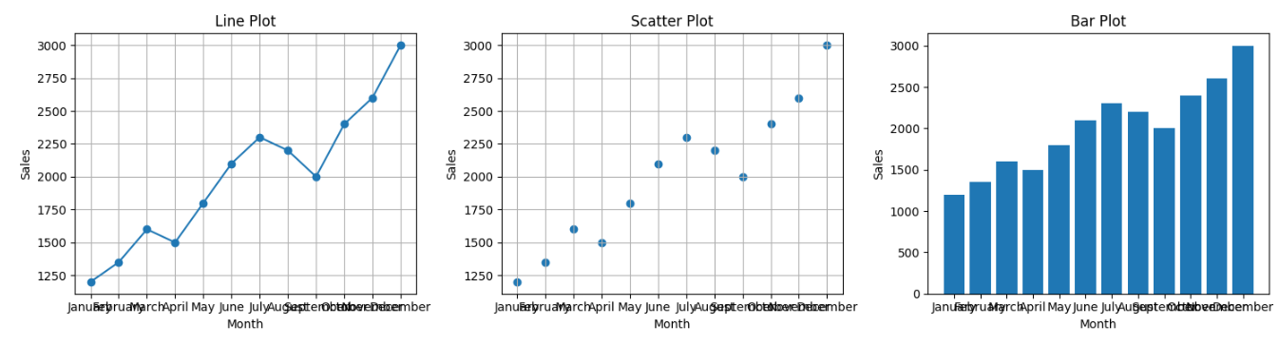
- import matplotlib.pyplot as plt
# Monthly data
months = ["Jan", "Feb", "Mar", "Apr", "May", "Jun",
"Jul", "Aug", "Sep", "Oct", "Nov", "Dec"]
temperature = [22, 24, 27, 30, 32, 34, 33, 32, 30, 28, 25, 23] # Example temps
rainfall = [80, 60, 50, 40, 30, 20, 10, 15, 40, 70, 90, 100] # Example rainfall
# Create figure (two graphs in one page)
plt.figure(figsize=(12, 6))
# --- 1. Line Plot for Temperature ---
plt.subplot(1, 2, 1) # 1 row, 2 columns, graph 1
plt.plot(months, temperature, marker='o')
plt.title("Monthly Temperature")
plt.xlabel("Months")
plt.ylabel("Temperature (°C)")
# --- 2. Scatter Plot for Rainfall ---
plt.subplot(1, 2, 2) # 1 row, 2 columns, graph 2
plt.scatter(months, rainfall)
plt.title("Monthly Rainfall")
plt.xlabel("Months")
plt.ylabel("Rainfall (mm)")
# Show all plots
plt.tight_layout()
plt.show()
OUTPUT:
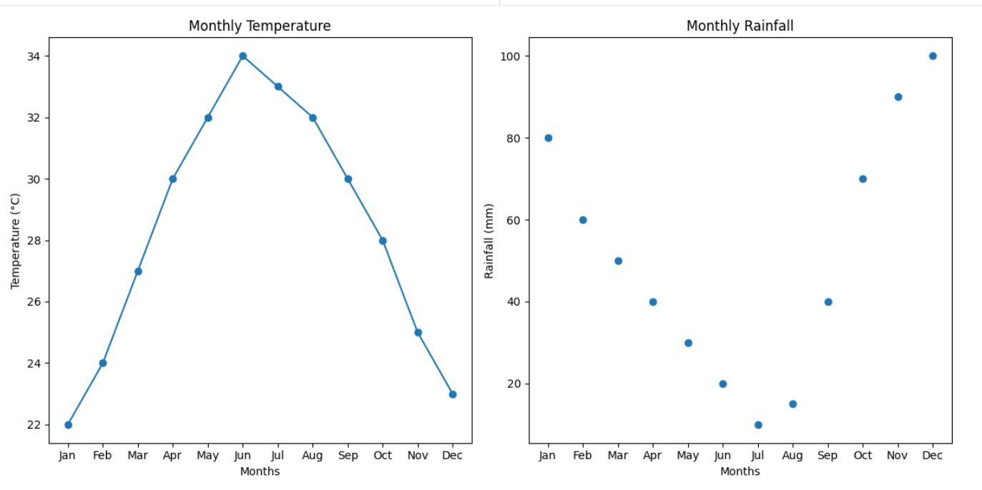

- from collections import Counter
import string
file = open("sample_text.txt", "r")
text = file.read().lower()
file.close()
# Remove punctuation
for p in string.punctuation:
text = text.replace(p, "")
words = text.split()
frequency = Counter(words)
print("Word Frequency Distribution:")
for word, count in frequency.items():
print(word, ":", count)

OUTPUT:
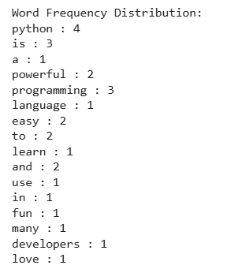

- import pandas as pd
data = pd.DataFrame({
"customer_id": [1,2,3,4,5,6],
"age": [25, 30, 25, 40, 30, 30]
})
age_freq = data["age"].value_counts()
print("Age Frequency Distribution:")
print(age_freq)
OUTPUT:
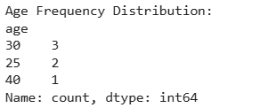

- import pandas as pd
posts = pd.DataFrame({
"post_id": [1,2,3,4,5,6],
"likes": [10, 20, 10, 15, 20, 10]
})
like_freq = posts["likes"].value_counts()
print("Likes Frequency Distribution:")
print(like_freq)
OUTPUT:
